Vertical axis wind turbine
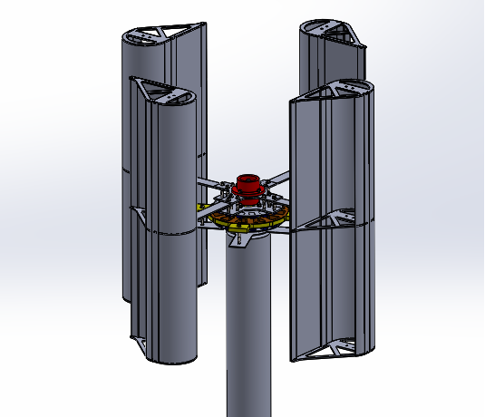
Abstract: A Renewable energy is defined as energy that comes from natural resources such as sun, tides, wind, geo thermal energy etc., there are two types of wind turbines. 1)Horizontal wind turbine 2) vertical wind turbine. In VAWT turbine blades are parallel to the axis. by using VAWT can generate energy through flow of wind. Vertical axis wind turbine has capable to rotate when wind is in any direction. A wind turbine extracts energy from moving air by showing the wind direction, and transforming the energy in to spinning shaft, which usually turns a generator into electricity. The power production is depending up on the flow of wind and rotation of turbine blades.
So the turbine, blades and other undergoes different loads when speed of the wind is very high.
The main objective of this project is to design the blades turbine disk and other components by using SOLID WORKS 2014 and can analyze and simulation con be done by simulation tool.

